PLC

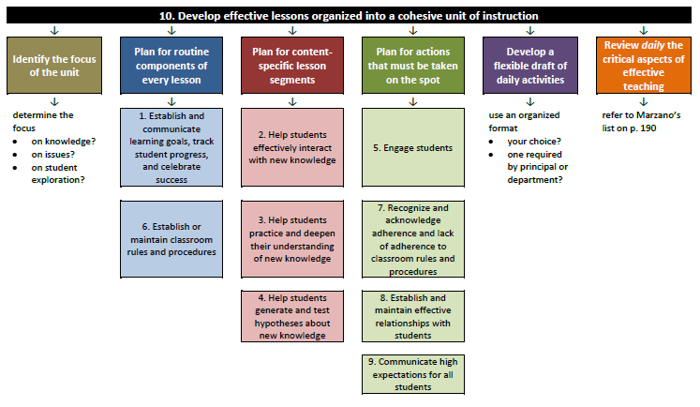

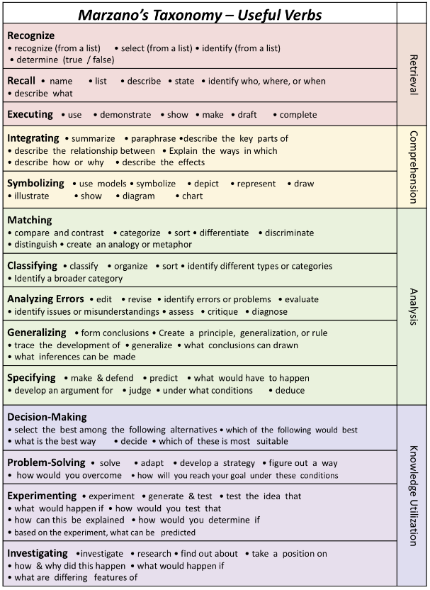

PLC Guiding Questions for Standards Based Teaching and Learning

- What do we want students to know and do?
  - TOPIC: Which topic will be the current focus for learning?

  - LEARNING GOAL(S): What is our common interpretation of the learning goal? What is the cognitive complexity of the learning goal?

  - LEARNING TARGETS: What are the learning targets based on our students’ needs? How do the targets fit into the scale?

  - ACTIVITIES: What activities align with the target? Does the cognitive complexity of the activity align to the cognitive complexity of the target?

    - How will the targets (cognitive complexity) get to the goal (cognitive complexity)?

- How will we know if students are learning?

  - ANALYSIS OF EVIDENCE: What evidence will we consider to monitor mastery of the goal? Does the evidence align to the cognitive complexity of the learning goal?

    - Can we use the collaborative scoring protocol to analyze outliers, the tool or activity?

- What do we do if students haven’t learned? What do we do if they’ve already learned it?

  - What strategies were effective and how do you know?

  - What do we need to reteach or spiral back for more practice?

  - What do we do if they already learned it? What might a level 4 look like? Multiple opportunities?

