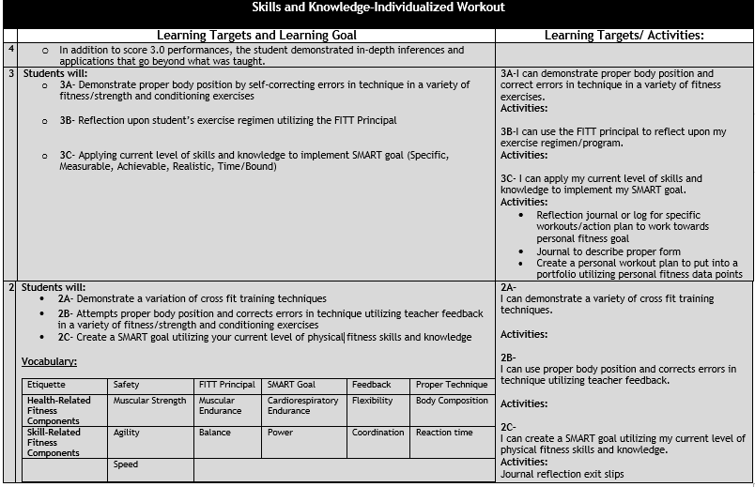

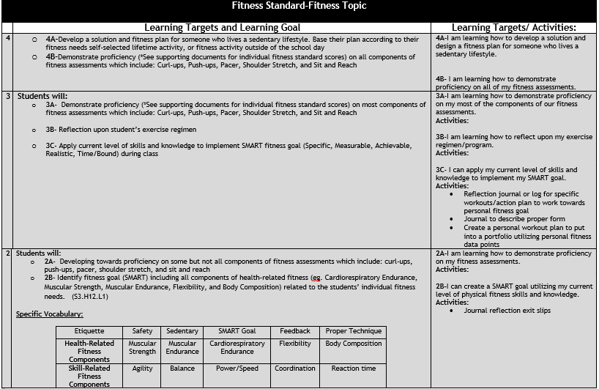

Day | Learning Targets | Evidence of Learning | Activities | Assignment(s)/Resources
1  A  B | Learning Target(s):  3B-I am learning how to reflect upon my exercise program.  3A- I am learning how to demonstrate proficiency on my fitness assessments. | Evidence:  -Visual Observation  -Workout sheets  -Reflection sheets  -Fitness Log | Activities (Agenda):  -Safety  -Routines and Procedures  -Warm-up (dynamic stretching)  -Pre-Assessment for Fitness Standards  -Cool-down  -Change | Assignment(s)/Resources:  -Start thinking about designing a program for someone who lives a sedentary lifestyle.  -Fitness Log  -Preview  -Pre-set Fitness Goals sheet
2  A  B | -Learning Target(s):  3A- I am learning how to demonstrate proficiency on my fitness assessments.  3B-I am learning how to reflect upon my exercise program. | Evidence:  -Observation  -Workout sheets  -Reflection sheets | Activities (Agenda):  -Safety  -Routines and Procedures  -Warm-up (dynamic stretching)  -Finish Pre-assessment for Fitness Standards  -Small group workout  -Fitness stations  -Cool-down  -Change | Assignment(s)/Resources:  -Start thinking about designing a program for someone who lives a sedentary lifestyle.  -Daily workout sheets
3  A  B | -Learning Target(s):  3B-I am learning how to reflect upon my exercise program.  2B-I am learning how to create a SMART Goal utilizing my current level of fitness skills and knowledge. | Evidence:  -SMART Goal  -Visual observation  -Workout sheets | Activities (Agenda):  -Warm-up (dynamic stretching)  -Fitness results  -SMART Goal creation  -Fitness stations  -Cool-down  -Change | Assignment(s)/Resources:  -SMART Goal worksheet  -Daily workout sheets
4  A  B | -Learning Target(s):  2B-I am learning the difference between skill-related fitness components and health-related fitness components  3B-I am learning how to reflect upon my exercise regimen/program.  3A-I can demonstrate proper body position and correct errors in technique in a variety of fitness exercises. | Evidence:  -Visual observation  -Workout sheets  -Muscle chart | Activities (Agenda):  -Warm-up (dynamic stretching)  -Small group rotations-determine muscles with group  -Upper body fitness- stations  -Abdominals and Plank workout  -Cool-down T25  -Change | Assignment(s)/Resources:  -Skill-related fitness components vs. Health-related fitness components worksheet  -muscle chart  -Daily workout sheets
5  A  B | -Learning Target(s):  3A-I can demonstrate proper body position and correct errors in technique in a variety of fitness exercises.  3B-I am learning how to I can use the FITT principal to reflect upon my exercise regimen/program. | Evidence  -Visual observation  -Workout sheets  -FITT Principal Exit ticket  -Muscle Chart  -Lower body checklist | Activities (Agenda):  -Warm-up (dynamic stretching)  -Quick vocab instruction FITT Principal  -Small group rotations  -Lower body fitness stations  -Cool-down Abs/Static Stretch  -Change | Assignment(s)/Resources:  -Skill-related fitness components vs. Health-related fitness components worksheet  -Daily workout sheets  -FITT Principal worksheet/reference guide
6  A  B | -Learning Target(s):  3A-I can demonstrate proper body position and correct errors in technique in a variety of fitness exercises.  3B-I am learning how to I can use the FITT principal to reflect upon my exercise regimen/program. | Evidence  -Visual Observation  -FITT Principal reflection sheet  -exit ticket  -Upper body checklist  -Design workout | Activities (Agenda):  -Warm-up (dynamic stretching)  -Quick vocab instruction FITT Principal  -Small group rotations  -Upper body fitness stations  -Cool-down Deep Breathing/Static Stretching | Assignment(s)/Resources:  -Unit Vocabulary Hand out  -Review sheet  -Daily workout sheets  -FITT Principal  worksheet/reference guide  -Steps to designing your individual workout
7  A  B | -Learning Target(s):  3A-I can demonstrate proper body position and correct errors in technique in a variety of fitness exercises.  3C- I can apply my current level of skills and knowledge to implement my SMART goal. | Evidence  -Visual observations  -Individual time to design workout plan  -Personalized checklist | Activities (Agenda):  -Warm-up (dynamic stretching)  -Design specific individual workout plan according to specific personal growth opportunities  -Upper body fitness stations  -Cool-down T25 | Assignment(s)/Resources:  -Steps to designing your individual workout  -Individual work out sheet  -Partner design/shuffle
8  A  B | -Learning Target(s):  3C- I can apply my current level of skills and knowledge to implement my SMART goal.  3A-I am learning how to demonstrate proficiency on my most of the components of our fitness assessments. | Evidence  -Visual observations  -Individual time to design workout plan  -Reflection Exit Ticket | -Activities (Agenda):  -Warm-up (dynamic stretching)  -Implement specific individual workout plan according to specific personal growth opportunities  -Upper body fitness stations  -Cool-down Deep Breathing/Static Stretching | Assignment(s)/Resources:  -Steps to designing your individual workout  -Individual work out sheet  -Partner design/shuffle
9  A  B | -Learning Target(s)  3C- I can apply my current level of skills and knowledge to implement my SMART goal.  3A-I am learning how to demonstrate proficiency on my most of the components of our fitness assessments.  -4A-I am learning how to develop a solution and design a fitness plan for someone who lives a sedentary lifestyle.  4B- I am learning how to demonstrate proficiency on all of my fitness assessments. | Evidence  -Vocab Assessment  -Fitness Post assessments  -Exit ticket  -Reflection form  -Visual observation  -Conversations | -Activities (Agenda):  -Warm-up (dynamic stretching)  -Implement specific individual workout plan according to specific personal growth opportunities  -Individual and group rotations  -Lower body fitness stations  -Cool-down T25 | Assignment(s)/Resources  -Unit Vocabulary Review  -Level 4 opportunity  -Develop a solution and design a fitness plan for someone who lives a sedentary lifestyle.  -District Fitness Tiered Assessment
10  A  B | - Learning Target(s)  3C- I can apply my current level of skills and knowledge to implement my SMART goal.  3A-I am learning how to demonstrate proficiency on my most of the components of our fitness assessments.  -4A-I am learning how to develop a solution and design a fitness plan for someone who lives a sedentary lifestyle.  4B- I am learning how to demonstrate proficiency on all of my fitness assessments. | Evidence  -Vocab Assessment  -Fitness Post assessments  -Exit ticket  -Reflection form  -Visual observation  -Conversations  -District Tiered Assessment | Activities (Agenda):  -Warm-up (dynamic stretching)  -Cardio  -Implement specific individual workout plan according to specific personal growth opportunities  -Individual and group rotations  -Fitness assessments post assessment  -Cool-down T25 | Assignment(s)/Resources  Finish the following/gather evidence:  -Unit Vocabulary Review  -Level 4 opportunity  -Develop a solution and design a fitness plan for someone who lives a sedentary lifestyle.  -District Fitness Tiered Assessment

